Via flow instructions, realize the cargo controlled
Summary
XC Series PLC’s offer 4 (four) instructions: STL, STLE, SET, ST. STL, STLE should be used in pairs. STL indicates the start of a flow, while STLE indicates the end of a flow. Executing SET Sxxx, Sxxx flow will be open, while the current flow will be closed. But, when executing ST Sxxx, flow Sxxx will be open but the current flow is not closed.
This example shows an automatic control flow of a cargo. The program executes the events step by step sequentially. Each step includes a series of actions. Also, only the conditions fulfill the requirements, the program can be executed.
Graph:
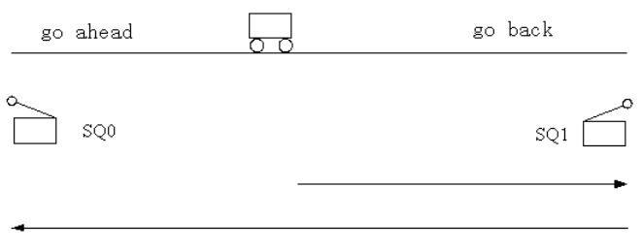
Flow Chart:
T1 time delay
Time delay S1
Empty flow S10
Cargo Forth S2
Remove the Materials /time-delay S3
T0 time reach
Forth limitation switch X3
Stop button X1
Main flow
Cargo back S0
Start button X0
Back limitation switch X4
Stop button X1
Stop button X1

Program Description:

After pressing the start button X0, the cargo will go back. When reaches back limitation switch X4, the cargo will stop and delay 5 seconds. When delay time reaches, the cargo will go forth. When reaches the forth limitation switch X3, the cargo will stop to remove the materials. After 8 seconds delay, the cargo will go back again. Unless you press down the stop button, the cargo will keep working in this loop

Program:
